**Polymers**

The word *polymer* is derived from two Greek words, poly and meros, where *poly* means many and *meros* means parts. Polymers are giant molecules formed by the combination of several simple molecules having two or more binding sites linked through covalent bonding.



The simple molecules which are repeating units of the polymer, are called monomers.

Eg: Polythene is formed by the combination of several ethene (ethylene) molecules.

**Degree of polymerization (DP)**: Degree of polymerization is the number which expresses the total number of repeating units (n) in the polymer chain. Polymers with large number of repeating units are called high polymers and those with lower number of repeating units are called oligomers.

DP is used to determine the molecular weight of the polymer by multiplying the number of repeating units (n) with the molecular weight of repeated unit.

**Functionality:** The total number of functional groups, bonding sites or reactive sites present in the monomer is called the functionality of the monomer. The reactive functional groups can be

–OH, -COOH, -NH2, -SH , –NCO etc.

Eg: In CH3CH2OH one reactive - OH group is present, hence functionality is one ( monofunctional)

HO- CH2 -CH2 – OH has two – OH groups hence bifunctional

HOOC CH2 CH (COOH) CH2 COOH has three -COOH groups, hence trifunctional

The presence of double or triple bonds in the molecule imparts polyfunctionality to the molecules.

Eg: Ethylene - due to the presence of a double bond, it can take on two atoms of hydrogen or halogens. Depending upon the functionality of the monomers used linear, branched or three dimensional cross-linked polymers are formed.

**Classification of polymers**

Polymers can be classified in several ways, based on their

* origin
* structure
* methods of formation
* response to heat and crystallinity
* properties (or applications)

Based on their ***origin****,* polymers are broadly classified as

(a) Natural polymers (b) synthetic polymers.

Natural polymers are those which are obtained naturally. Eg: Cellulose, Silk, Starch

Synthetic polymers are those which are man-made. Eg: polythene, PVC, polyster, etc.

Semi-synthetic polymers are chemically modified natural polymers. Eg: cellulose acetate, cellulose nitrate, halogenated rubbers etc.

Based on their ***molecular structure***, the polymers can be classified as

(a) Linear (b) Branched (c) Cross-linked

If all the monomeric units are identical and combine linearly with each other to form a polymer, it is called a *linear homopolymer*.

Eg. - M – M – M – M – M – M – M - …………

If the monomeric units are not identical, it is called a *linear co-polymer*.

Eg: -M – M1 – M – M1 – M – M1 – M - …………

If the linear co-polymers in which the units of each type form fairly long continuous sequences (blocks) are called *block co-polymers.*

Eg., ………..- M – M – M – M - M1 – M1 - M1 - M1 - M – M – M – M – …………

If the linear polymer branches out, then it is called a *branch polymer*.

The polymers can be classified as follows, on the basis of their ***method of formation***

(a) Addition polymers (b) condensation polymers

Addition polymers are formed by a process of self-addition of monomers without the elimination of any byproducts. Eg: Polyethylene & synthetic rubbers.

Condensation polymers are formed by condensation reaction i.e., reaction between two or more monomer molecules with the elimination of simple molecules like water, ammonia, HCl etc.,

Eg: Urea-formaldehyde resins, phenol-formaldehyde resins & polyesters.

The polymers can be classified on the basis of their ***response to heat***as follows.

(a) Thermo softening (b) Thermosetting

The polymers, which soften on heating and can be converted into any shape, which they can retain on cooling, are called as thermo softening or thermoplastic polymers. The process of heating, reshaping and retaining the same on cooling can be repeated several times. Eg: polyethylene, nylons , sealing wax.

The polymers which undergo some chemical change on heating and convert themselves into an infusible mass are called as thermosetting polymers. Eg: bakelite, egg yolk.

Based on their ***application and properties*** polymers are classified as follows.

(a) Plastics (b) Elastomers (c) Fibers (d) Resins

Plastics are the polymers, which are soft enough at some temperature to be moulded into a desired shape and hardened on cooling so that they can retain that shape. Eg: polystyrene, polyvinyl chloride , poly methyl methacrylate.

Elastomers are polymers in which the structural units are either zig zag or helical chains. They undergo elastic changes when subjected to an external force, but readily regain their original shape when the force is withdrawn. Eg: natural rubber, silicone rubbers.

Fibres are characterized by their molecular chains arranged parallel to each other in a spiral or helical pattern which do not undergo stretching or deformation and the molecular length is at least 100 times its diameter. Eg: nylons, terylene.

Resins are much lower molecular weight polymers either in liquid or solid form used as adhesives or moulding powders. It has a glossy appearance. Resins constitute the major essential part of the plastics. Eg: Polysulphide sealants,epoxy adhesives.

**Polymerization**

Polymerization is defined as the process by which the monomer molecules are linked to form a big polymer molecule .

**Types of Polymerization:**

Polymerization occurs basically in two different modes.

1. Addition (chain growth) polymerization

2. Condensation (step growth) polymerization

**Addition polymerization:** The reaction in which self-addition of several olefinic monomers to each other takes place without elimination of by products is known as addition polymerization. The addition polymerization must be initiated by using heat or light or pressure or catalyst for the breakage of the double bonds of monomers.

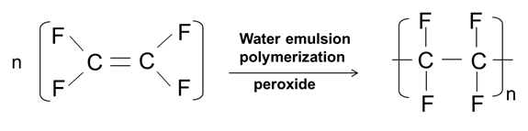

**Condensation Polymerization:** The reaction in whichmonomers containing two or more reactive functional groups (hydroxyl, carboxyl, amino) condensing with each other.

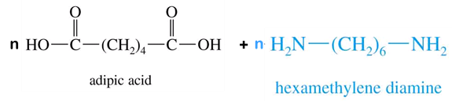

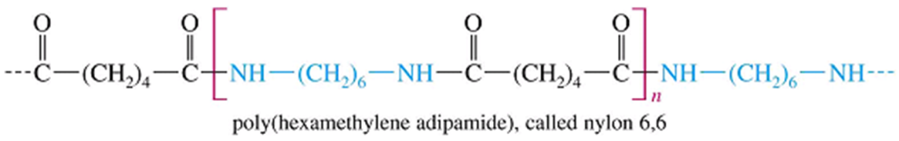

**Distinguishing features of addition and condensation polymerisation**

|  |  |
| --- | --- |
| **Addition polymerisation** | **Condensation polymerisation** |
| * Monomers undergo self addition to eah other without loss of by products * It follows free radical mechanism (Chain mechanism) * Unsaturated vinyl compounds undergo addition polymeristion * Monomers are linked together through C – C covalent linkages * High polymers are formed fast * Linear polymers are produced with or without branching * Examples: polystryrene, plexiglass, PVC, etc. | * Monomers undergo intermolecular condensation with continuous elimination of by products such as H2O, NH3, HCl, etc., * It follows step mechanism * Monomers containing the functional groups(-OH,-COOH,-NH2) undergo this polymerization * Covalent linkages are through their functional groups * The reaction is slow and the polymer molecular weight increases steadily throughout the reaction * Linear or cross linked polymers are produced * Examples: nylons, terylene, PF resins, etc. |

**Stereo regular polymers (Tacticity in polymers)**

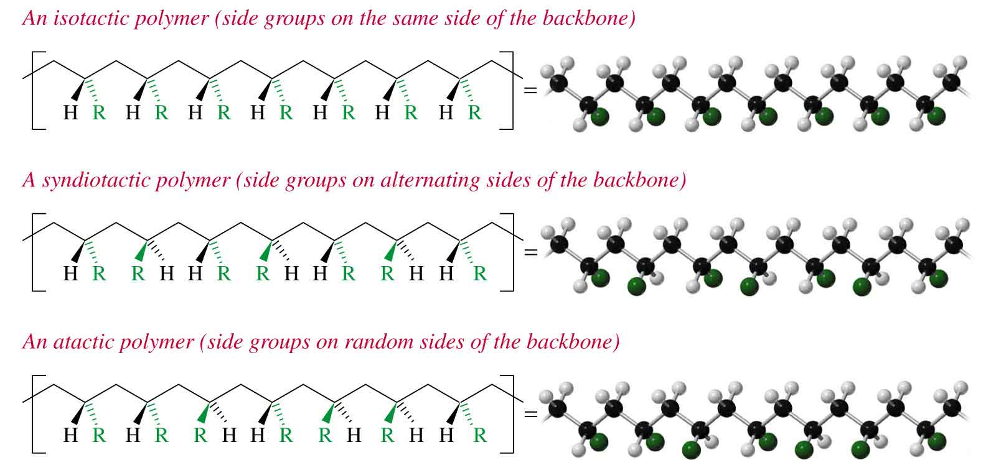This classification is based on the position of the substituent groups in the polymer chain. Depending on the position and regularity of the repeating substituent groups, three different arrangements can be visualized- isotactic, syndiotactic and atactic.

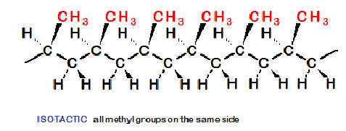

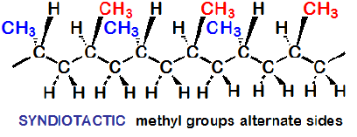

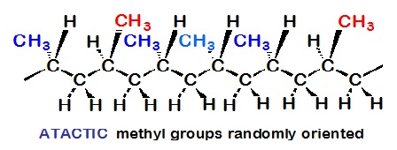

**Structure and properties of polymers**

The structure of a polymer has profound influence on some of the properties of polymers .The properties such as crystallinity, tensile strength, elasticity, resistance to chemicals and plasticity depend mostly on the polymer structure and are discussed below.

**Strength:** This property is discussed based on forces of attraction and slipping power.

*Based on forces of attraction:* Strength of the polymer is mainly determined by the magnitude and distribution of attraction forces between the polymer chains. These attractive forces are of two different types viz., primary or covalent bond and secondary or intermolecular forces.

In case of straight chain and branched chain polymers, the individual chains are held together by weak intermolecular force of attraction. But in these polymers, strength increases with increase in chain length (increase in molecular weight) i.e., attains mechanical strength if the chain length is greater than 150 – 200 carbon atoms in the chain. Less than these numbers, the polymers will be soft and gummy, but brittle at low temperature. Intermolecular forces can be increased by introducing polar groups like carbonyl & hydroxyl.



In cross-linked polymers, monomeric units are held together only by means of covalent forces. Hence possess greater strength than straight and branched chain.



***Based on slipping power*:** Slipping power is defined as movement of molecules one over the other. Eg: polyethylene molecule is simple and uniform, hence movement of molecule one over other is possible, i.e., slipping power is high. Hence it has lesser strength. But in case of polyvinyl chloride (PVC), bulky chlorine atoms are present along the chain length hence, movement is restricted, i.e., slipping power is less. Hence it has higher strength compared to polyethylene. But in case of cross-linked polymer, movement is totally restricted because of the presence of covalent bond. Hence these products are strong, rigid and tough.

**Plastic deformation:** When a polymer is subjected to some stress in the form of heat or pressure or both, permanent deformation in shape takes place, which is known as plastic deformation. This property actually helps in moulding of plastics. Slippage is more in case of linear molecules than branched and cross-linked, because of the presence of weak intermolecular forces and hence they show greatest degree of plastic deformation. At high pressure and temperature the vander Waal‘s forces acting between molecules become more and more weak. No slippage occurs in case of cross-linked polymers, because only strong covalent bonds are present throughout the entire structure. However, when considerable external force or temperature exceeding the stability of material is applied, it will result in total destruction.

**Crystallinity:** Based on the relative arrangement of polymer chains with respect to each other, polymer can exhibit amorphous and crystalline nature. An amorphous state is characterized by completely random arrangement of molecules and crystalline form by regular arrangement of molecules. The crystallization tendency of a polymer depends on the ease with which the chains can be aligned in an orderly arrangement. Crystalline regions of a polymer are formed when the individual chains are linear (without branching), contain no bulky substituents and are closely arranged parallel to each other. The chains of polymer may be held together by vander Waal‘s forces, hydrogen bonding or polar interactions. A polymer with high degree of crystallinity will have high tensile strength, impact and wear resistance, high density and high fusion temperature. Polymers with a long repeating unit or with low degree of symmetry do not crystallize easily, hence forms amorphous structure e.g., polystyrene. Crystallization imparts denser packing of molecules due to increase of intermolecular forces of attraction. Such type of polymers will have sharp softening point, greater strength and rigidity. e.g PVC, Polypropylene. Polymers are in general, amorphous with some degree of crystallinity.

**Chemical Resistance:** Chemical resistance of polymer depends upon the chemical nature of monomers and their molecular arrangement. A polymer is more soluble in structurally similar solvent. For example, polymers containing polar groups like – OH, - COOH, usually dissolve in polar solvents like water, alcohol etc but are chemically resistant to non-polar solvents. Similarly non-polar compounds like hydrocarbons dissolve only in non-polar solvents like benzene & toluene.

As a general rule, the tendency of solubility in a particular solvent decreases with increase in molecular weight of the polymer- (i) high molecular weight polymer on dissolving yield solutions of high viscosities (ii) crystalline polymers exhibit higher resistance than less crystalline polymers of similar chemical character (iii) greater the degree of crystallinity, lesser is its solubility.

Today several drugs and essential oils are stored in plastic bottles for long shelf life. If they disintegrate or change in their chemical composition they may render the drug ineffective or may cause it to react adversely when used, leading to specific disorder. Therefore, chemical resistance of plastic bottles is important to prevent drug polymer interactions.

**Elasticity:** Elastic nature in polymers results due to the uncoiling and recoiling of the molecular chains on the application of force. In an upstretched elastomer we can observe a peculiar configuration of irregularly coiled and entangled snarls in a random fashion, indicating the amorphous state. In a stretched state snarls disentangle and straighten out in a proper chain orientation, indicating the crystalline state. The crystallinity in a stretched rubber band can be observed from its opaqueness and warmth it produces when touched by lips. The main criteria for a polymer to show elastic nature is that , the individual chains should not break even after prolonged stretching. This can be done by introducing suitable crosslinking in the chains, by allowing nonpolar groups or side groups in the repeating unit.

**Glass transition temperature Tg**

Amorphous polymers do not have sharp melting points. They possess softening point. At low temperature, polymers exist as glassy substances. Since the molecular chains cannot move at all easily in this state, the solid tends to shatter, if it is hit. If the solid polymer is heated, eventually it softens and becomes flexible. This softness and flexibility is obtained at the glass transition temperature. After this temperature, crystalline and amorphous thermoplastic polymers behave differently. Heating has little effect on thermosetting polymers and at a high temperature, they are destroyed.

So the ***glass transition temperature*** can be defined as the temperature below which an amorphous polymer is brittle, hard and glassy and above the temperature it becomes flexible, soft and rubbery.

Glassy state rubber state

(Hard brittle plastic) (soft flexible)

In the glassy state of the polymer, there is neither molecular motion nor segmental motion. When all chain motions are not possible, the rigid solid results. On heating beyond Tg segmental motion becomes possible but molecular mobility is disallowed. Hence flexible,

**Factors affecting glass transition Temperature**

Glass transition temperature of a polymer depends on parameters such as chain geometry, chain flexibility, molecular aggregates, hydrogen bond between polymer chains, presence of plasticizers and presence of substrates in the polymer chains.

A polymer having regular chain geometry show high glass transition temperature, the bulky groups on chain increases the Tg of the polymer. E.g., polyethylene has Tg -110 oC. The Tg is quite low because there are no strong intermolecular forces and no bulky side groups are present, the side chain is only hydrogen atom. But nylon 6 has Tg 50 oC because of the presence of large number of polar groups in the molecule leading to strong intermolecular hydrogen bonding.

The Tg of a polymer is influenced by its molecular weight. However, it is not significantly affected if molecular weight is around 20000. With increase in molecular mass, the temperature (Tg ) will be higher.

In crystalline polymers the polymer chains are arranged in a regular parallel fashion. Each chain is bound to the other by strong forces like H-bonding. Hence crystalline polymers have higher Tg than amorphous polymers.

The added plasticizers reduce the Tg of the polymer by reducing the cohesive forces of attraction between the polymers. e.g., dibutyl phthalate, diacetyl phthalate etc.,

The glass transition temperature is an important parameter of polymeric material. This helps in choosing the right processing temperature. It is a measure of flexibility of a polymer and also gives the idea of the thermal expansion, heat capacity, electrical and mechanical properties of the polymer.

**Molecular weight of polymers**

A polymer comprises of molecules of different molecular weights and hence, its molecular weight is expressed in terms of an ‘average’ value. Eg. In ethylene gas each of its molecules has the same chemical structure and hence, a fixed molecular weight of 28. But upon polymerization, it forms polyethylene and we encounter an indefinite chemical structure of --(-CH2 – CH2 -)n—where ‘n’ can change its value from one polyethylene molecule to another present in the same polymer sample.

When ethylene is polymerized to form polyethylene, a number of polymer chains start growing at any instant, but all of them do not get terminated after growing to the same size. The chain termination is a random process and hence, each polymer molecule formed can have a different number of monomer units and thus different molecular weights.So a sample polymer can be thought of as a mixture of molecules of the same chemical type, but of different molecular weights.

In this situation, the molecular weight of the polymer can only be viewed statistically and expressed as some average of the molecular weights contributed by the individual molecules that make the sample.

So the molecular weight of a polymer can be expressed by two most and experimentally verifiable methods of averaging - (i) Number – average and (ii) weight – average.

***Number – average molecular weight:*** Number average molecular mass of a polymer can be defined as the total mass of all the molecules in a polymer sample divided by the total number of molecules present.

***Weight – average molecular weight:*** The sum of the fractional masses that each molecule contributes to the average according to the ratio of its mass to that of the whole sample.

White foam cups, clear plastic cups and ultrathin fishing line are made of polystyrene with different average molar masses while styrofoam cups are made from beads of polystyrene with an average mass of approximately 15000 g/mol. Clear plastic cups are made by melting polystyrene with average mass of approximately 250000 g/ mol. Ultrathin fishing lines are composed of polystyrene with an average mass of 1000000 g/ mol.

**Application of Average molecular mass (AMM)**

It is used to characterize a polymer. Samples of the polymer prepared under different conditions may have different AMM. It affects the mechanical, solution & melt properties of the polymer. Chain length is related to the ease of processing of the polymer. The longer the chain, the more difficult the melt is to process. The polymer chain becomes more entangled as the molecules get larger and offer more resistance to flow at the molecular level. In most applications, the polymer must be able to flow so that it can be flattened into sheets, moulded into bottles and so on.

**Numerical Problems**

1. Calculate the number average & weight average molecular weight of a polymer sample in which 40 % molecules have molecular mass of 25000, 20 % have molecular mass of 30000 & rest have molecular mass of 55000.
2. A polymer sample contains 1, 2, 3 & 4 molecules having molecular weight 105, 2x 105 , 3x 105 and 4x 105 respectively. Calculate the number average & weight average molecular weight of the polymer.